

VSSC Printer Order/ Removal Process

REVISION HISTORY SUMMARY

Date | Version | Changed By | Revision Summary
08/30/10 | 1.0 | James Robbins | Initial release of document
09/01/10 | 2.0 | James Robbins | Updated document with ‘Expedited’ order process
09/01/10 | 3.0 | Sheetal Swamy | Updated Page 17, to display ship date entry and changed document format
09/15/10 | 4.0 | Sheetal Swamy | Update to Page 3, paragraph 1 further detailing how to handle ‘Consultations without Hardware’
06/05 12 | 5.0 | Sheetal Swamy | Reviewed process and validating it as current. No additional changes made to the content.
10/25/12 | 6.0 | Advocate Team FY’13 | Updated existing process to include all scenarios in the case VSSC supports all JIT peripheral ordering
04/15/13 | 7.0 | Advocate Team FY ‘13 | Include Peripheral removal process
04/25/13 | 10.0 | Advocate Team FY’13 | Remove any original PID reference
05/10/13 | 11.0-17.0 | David Hernandez, Cindy Norton | Update with contact procedures and edits regarding VSSC employee number assignments. Added Table of Contents and FSSC to VSSC Printer process flow. Updated End of Document ISO notation, changed title and saved name of document. Add details regarding systype and printer description match. Edit reference of unscheduled/scheduled workloads instead of employee numbers. Update verbiage on sub arf section. Add Lost/Stolen Procedures. Reformatted and updated table of contents. Defined Laser Printer and changed 2 days on Lost/Stolen Procedures
08/29/13 | 18.0 | Advocate Team | Changed documentation to reflect that FSSC will send all supported upgrades to Austin.
09/23/13 | 19.0 | David Hernandez | Added Printer Reference section
10/29/14 | 20.0 | David Hernandez/Sheetal Swamy | Added deleting drop ship address, removed contact customer reference, updated verbiage to reflect VSSC.
01/09/14 | 21.0 | David Hernandez/Mike Schmelzer | Adding verification process and changing current flow.
01/09/14 | 22.0 | David Hernandez/Mike Schmelzer | Added System Types.
01/23/14 | 23.0 | David Hernandez/Mike Schmelzer | Added Verifying Active Meters and System Types in one section.

Table of Contents

FSSC and VSSC Process Flow 4
Original PID is submitted from sales: 4
Verifying Active Meter and System Type 5
Upgrade Procedures. 7
Closing Out Nexus Upgrade Request 13
Drop Ship Procedures 15
Expedites and Multiples Orders 17
Lost/Stolen Procedures 21
Removals 23

FSSC and VSSC Process Flow

Original PID is submitted from sales:

- FSSC
  - Reviews request
    - FSSC will transfer all supported Upgrades to VSSC.(MAC Printers are not Supported)
    - FSSC will transfer Scan Gun orders to CIC.
  - Confirms ARF is a “Consultation with Hardware” request.
  - Verify Meter is on the account to order.
  - Transfer to VSSC Employee ID that is designated for unscheduled ARFs.

- VSSC
  - Receives “Consultation with Hardware” from FSSC.
    - Order peripherals based on printer order job aid.
      - Verify active meter in Infotool.
      - Please note that only the following sys types qualify for peripheral orders.
        - FSM Software Only (200, 210 and 280)
        - FedEx Dotcom (105)
- FXRS Software Only (510)
- FXRS Software Only-Child (511)
- Web Services XML (550)
- Web Services CSP (555)
    - Provide Sales an email update per current process with the following Information.
      - The number of printer/scales with the appropriate reference has been ordered with a requested ship date of xx/xx/xx.
      - If there was a request for multiple printers the number of printers ordered is included for confirmation for the AE.
        - If the CAHM process is used the CAHM reference. ID is copied and pasted into the AE correspondence email.
    - VSSC completes request

Verifying Active Meter and System Type

Log into Infotool: https://it.ts.fedex.com/login.aspx?ReturnUrl=%2fdefault.aspx
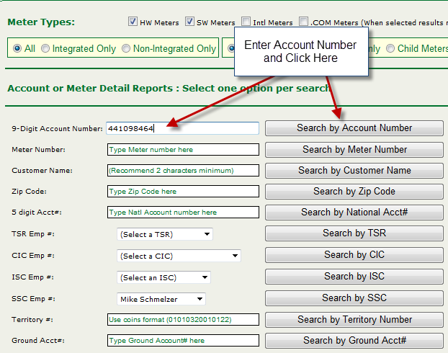
Enter Account number and select “Search by Account Number”.

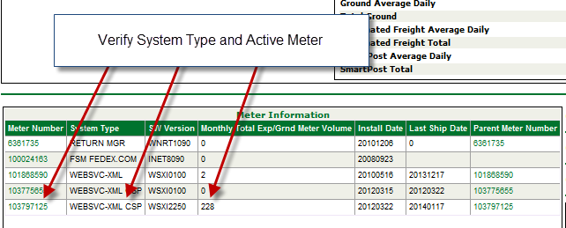

Verify the correct System Type.
  - FSM Software Only (200, 210 and 280)
  - FedEx Dotcom (105)
  - FXRS Software Only (510)
  - FXRS Software Only-Child (511)
  - Web Services XML (550)
  - Web Services CSP (555)

- Verify the Active meter by viewing the “Monthly Total Exp/Grnd Meter Volume” column. Select the meter with the higher volume and latest install date (displayed in YYYYMMDD).
Once verified please follow the upgrade Procedures.

Upgrade Procedures.
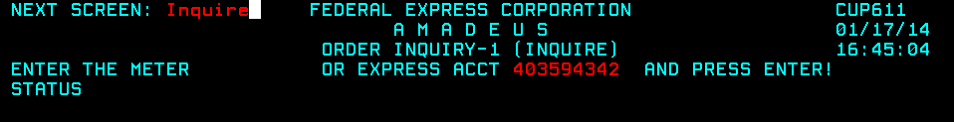
If you already have a cheers screen open you can just enter “Inquire” into the next screen field
Enter the account number to view all available meter numbers.
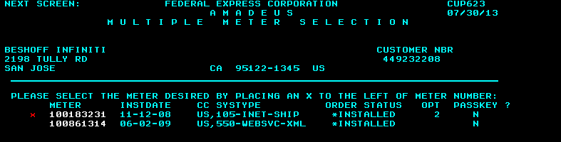
Select the meter number to be used for the upgrade. (enter an “x” next to the meter number to select).
* Please note that only the following sys types qualify for peripheral orders.
        - FSM Software Only (200, 210 and 280)
        - FedEx Dotcom (105)
- FXRS Software Only (510)
- FXRS Software Only-Child (511)
- Web Services XML (550)
- Web Services CSP (555)

Confirm address is correct proceed to upgrade.

*If contact name needs to be updated use the CHGLOC screen in AMADEUS to update the correct contact name. Verify Company Name is Present - See Change Location procedures.
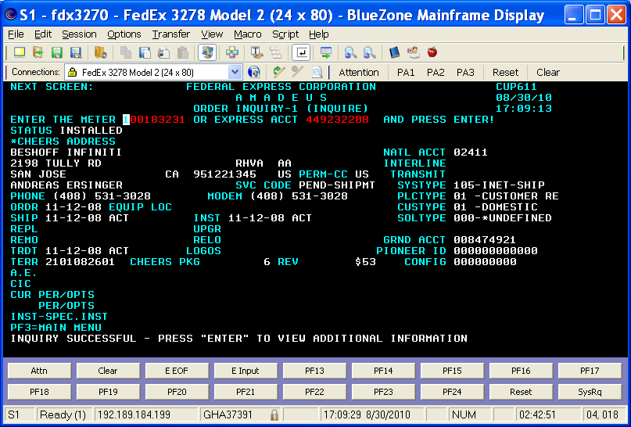
*If there is a Permanent drop ship address, verify address is the same as PID. If not, remove the drop ship address. Verify Company Name is Present –See Drop Ship procedures.
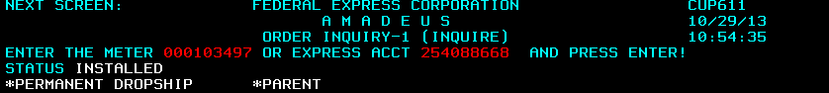

Type Upgrade in the NEXT SCREEN field and press Enter.
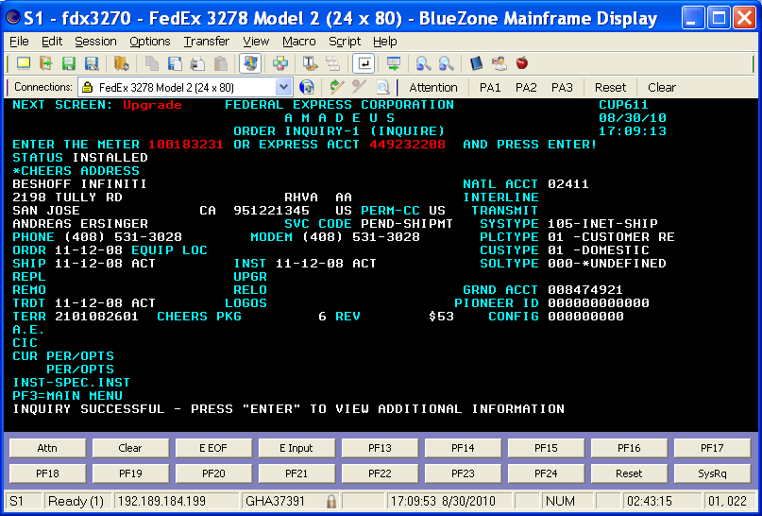

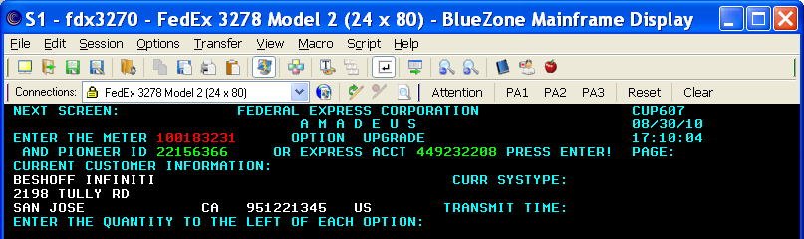
*VERIFY company name is showing in the Current Customer Information. See DropShip procedure to change or remove it.
Enter the Pioneer ID from the Upgrade request and <enter>.

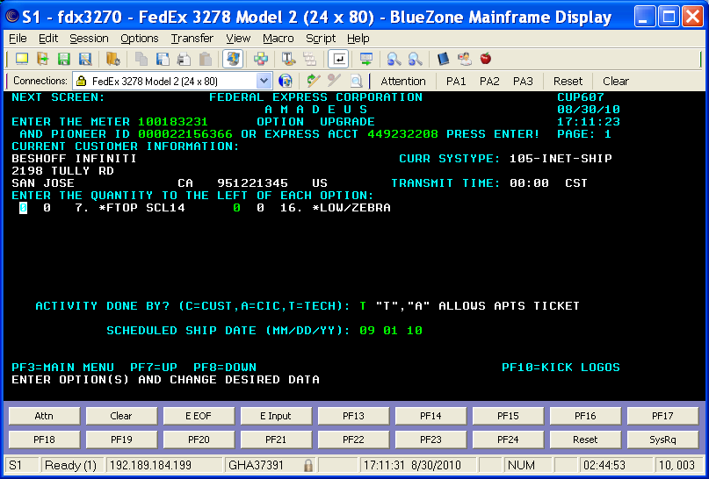
Enter “1” for either the Flat Top Scale and/or the Low Speed Zebra Printer.
- You can only order one scale and printer per meter number.
  - If multiple printer or scale requests are needed. You can utilize multiple meters on the account using the same pioneer ID from the Upgrade request.
*If only one meter is available for multiples of the same peripheral on the order, refer to the CAHM exception process.

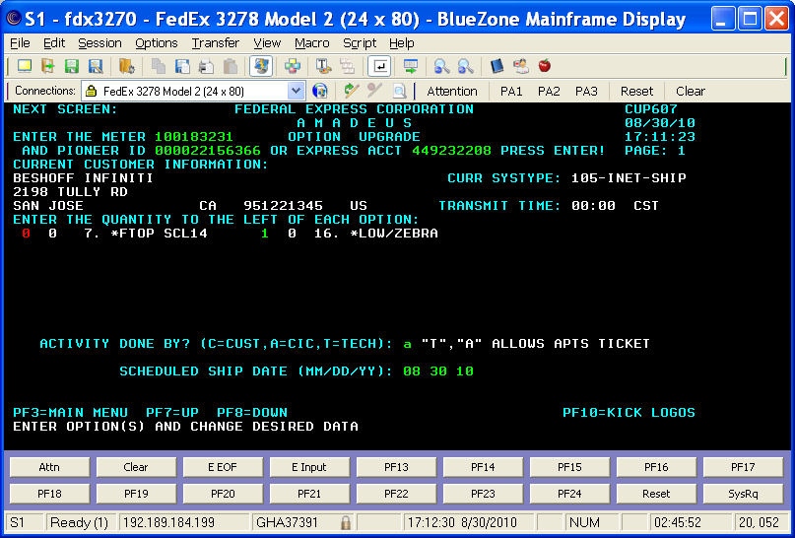
- Select “A” as the “Activity Done By”.
- Enter the current date in the “Scheduled Ship Date” field.
- Enter Y and hit enter to confirm.
- Press <F10> to Kick Logos.
- Once the transaction is sent you will see, “Logos transaction successfully sent for meter”
*The equipment will ship 2-day from the scheduled ship date
For next day delivery always enter a CAHM exception request.* (Orders must be submitted before 6:00pm Central time to be processed the same day). If processing order after 6:00pm CST, enter next day’s date as the ship date. Then hit <ENTER>.

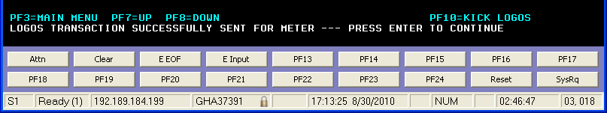
Printer Reference Guide
Sales Reference: | Name | Sales Reference: |  | Name | Additional Notes
(Default)Small Flat Top Scale, Scale | 14" FTOP SCALE | Roll Top Scale | 14" RTOP SCALE |  | Large scales are order if the customer needs to weigh over 150lbs.
Large Roll Top Scale | 20" RTOP SCALE | Large Ball Top | 20" BTOP SCALE |  | Small Scales are used for 0-150lbs
Small Ball Top | 14" BTOP SCALE | Large Scale | 20" FTOP SCALE |  | Laser Printers are used for End of Day reporting or other document printing for Haz and International.
X (Dot Matrix Printer) | I 2480 | X | 4800 GUN
X | 4006 GUN | (Default)Laser Printer( Regular full size laser document Printer) | Laser Printer |  | (Default) Should be default order unless specified otherwise.
X | LCD MONITOR | (Default)High Speed Printer, Large Printer(New Model) | Z4M PRINTER |  | (Older Model)=Not sent by default unless specifically asked.
(Specific)End of Day Dot Matrix Printer (Old) | RPT PRINTER | (Specific)Dangerous Goods Printer | DG 2480 |  | (Specific) =Unless noted specific model do not order
(Specific)International Dangerous Goods Printer | IDG 2480 | High Speed Printer(Older Model) | LG THERMAL / 2348 |  | X= Do Not Order
Small Printer, Thermal Printer, JIT Printer, Printer(Old Model) | SM THERMAL / 2844 | (Default) Small Printer, Thermal Printer, JIT Printer, Printer | ZP500 PRINTER
X | Other

Closing Out Nexus Upgrade Request

On the Upgrade request you will need to click “Refresh Display”. Depending on how the account is assigned the assigned CIC and AE information may disappear. Provide sales email update per current process with the following Information.
*Note: You do not have to email the FSSC
  - The (number) printer/scale (appropriate reference) has been ordered with a requested ship date of xx/xx/xx.

  - If there was a request for multiple printers the number of printers ordered is included for confirmation for the AE.

    - If the CAHM process is used the CAHM reference. ID is copied and pasted into the AE correspondence email

Helpful Hint: If you send the email to the AE before Refreshing the display, you will not need to reenter their ID number.
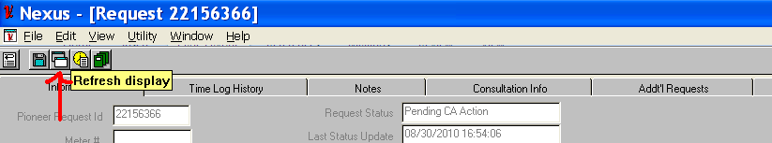

After refreshing the screen if the CIC field is blank on FedEx.com meters…
*Software requests will default to the original CIC (SSC) employee number
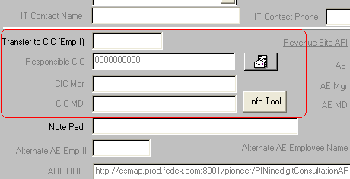
Enter your (VSSC) employee number and save. The request will now move from” Pending CA action” to ”Upgrade in Progress”.
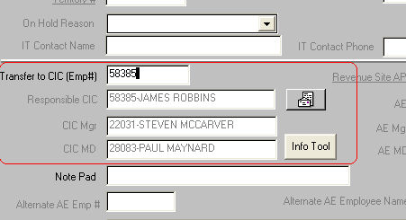

The printer/scale ordering process has now been completed.

Drop Ship Procedures
In Amadeus type in NEXT SCREEN: dropship
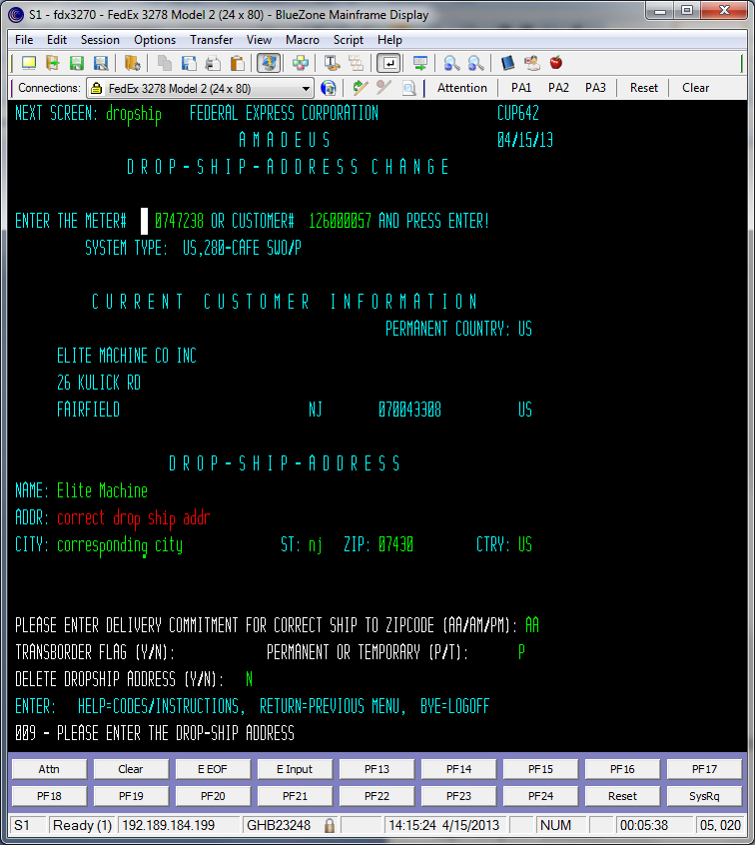
- Enter correct drop ship address
  - Verify Name is present.
- P for Permanent
- Enter to save

To delete a drop ship address enters a “Y” in the “DELETE DROPSHIP ADDRESS” field.
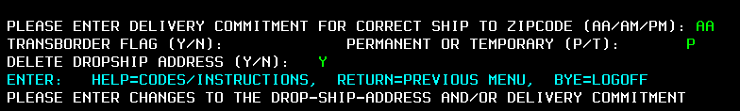

Expedites and Multiples Orders
Please remember Upgrades will ship *FedEx 2 Day (E2). If an expedite is necessary, you must order utilizing CAHM and request the order be expedited. Additionally, you need to utilize Cahms for multiple peripheral orders.
Log in to Amadeus and verify PID Contact/Address information matches.
*If contact/address is not correct see Change Location procedures.
If information is correct, proceed.
From the SSC home page select the CAHM icon. 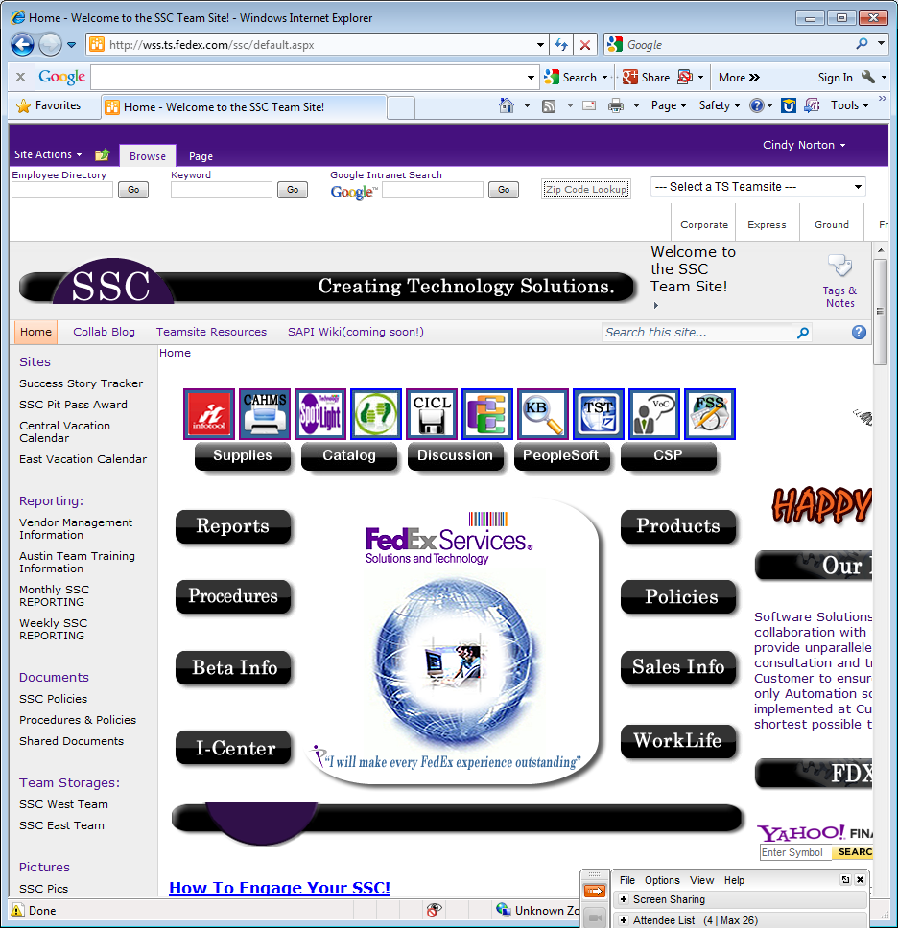
Log in using LDAP password
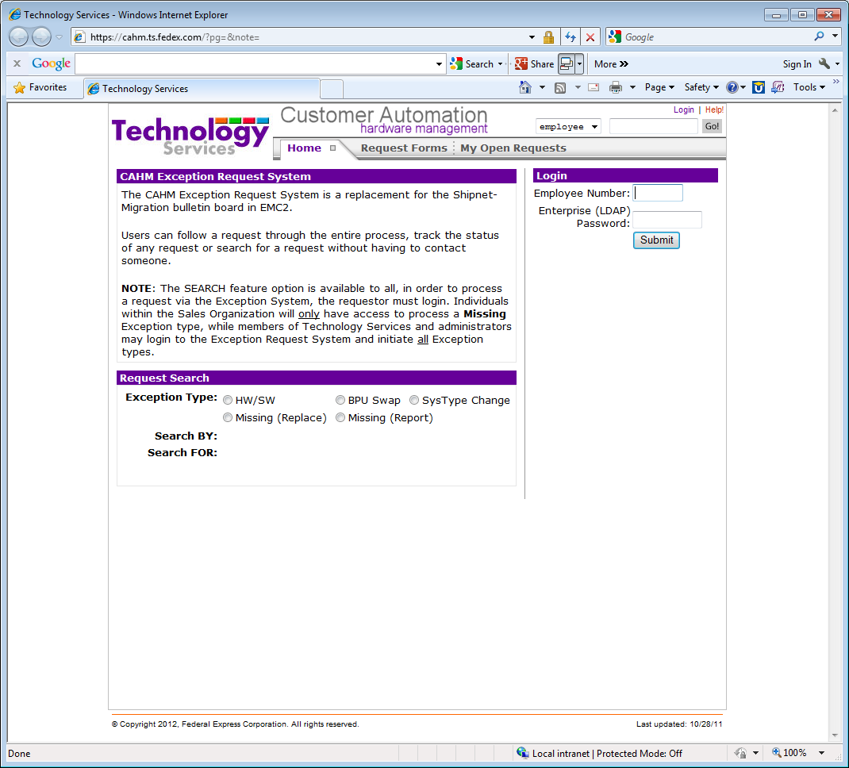
Select Request Forms
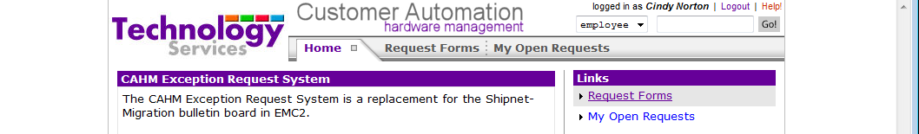

From the drop down menu select Hardware/Software
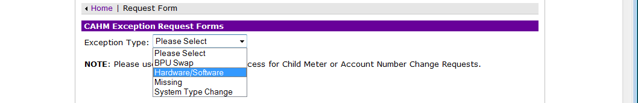
Enter the pioneer id from the upgrade request in Nexus
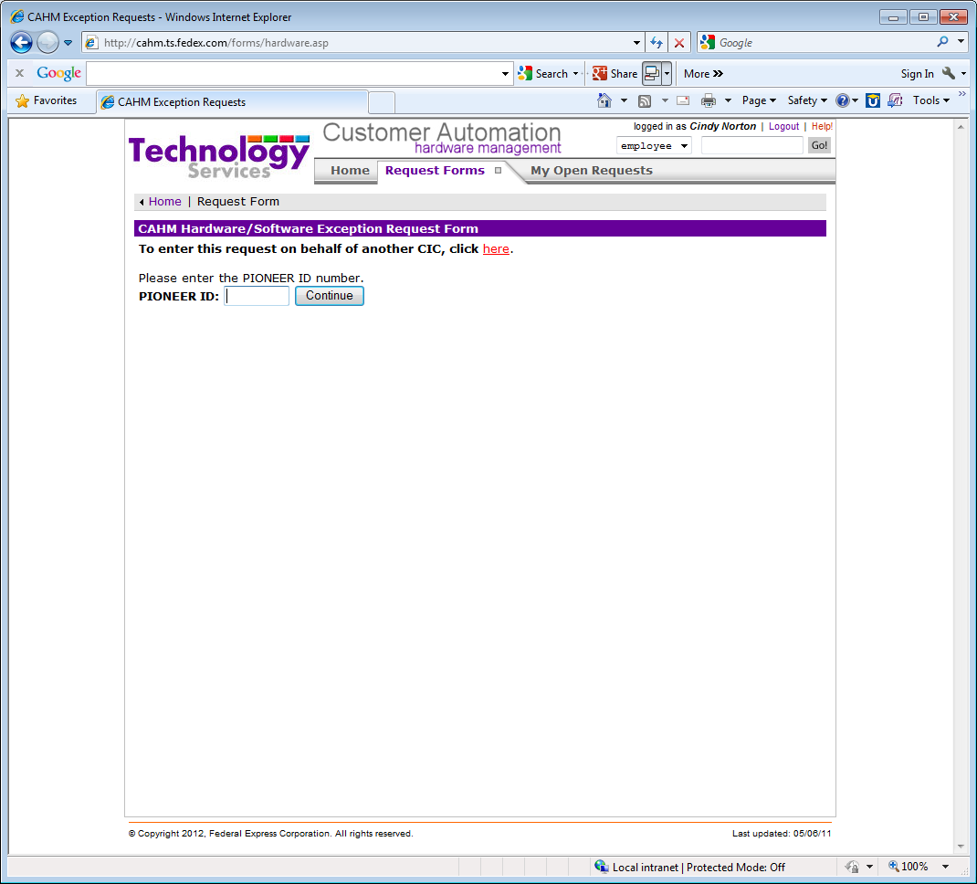

Enter all the highlighted fields:
- Ship date
- Expedite Check Box
- Select Meter Number
- LAN
- Installed by: TSR
- Equipment Location: Shipping
- Enter the number of peripherals requested(Multiple printer or scale orders)
- IF customer requests a “NETWORK printer” add comments: Provide Printer with Ethernet Card. Click Submit when Completed

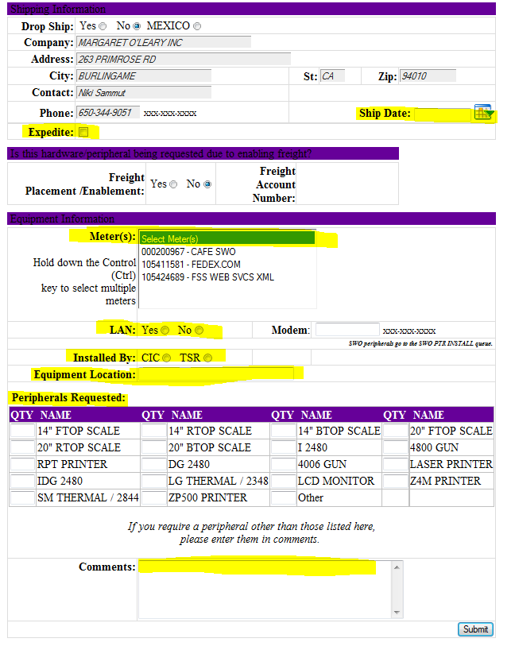
In Nexus Select on Hold Reason: CAHM exception submitted
*Verify the Cahm Address matches the Meter Address.

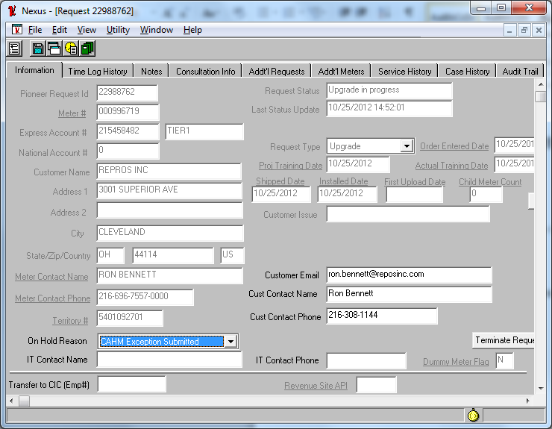
*In Notepad section: Enter 2 days from today’s date.

Lost/Stolen Procedures
From the SSC home page select the CAHM icon.

Log in using LDAP password

Select Request Forms

From the drop down menu select Missing.
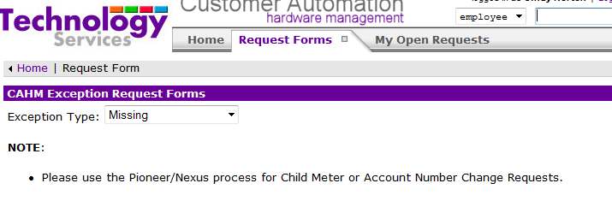
Enter Meter number:
- Sales should provide meter number in comments.
- If no meter then check Amadeus Inquire screen.
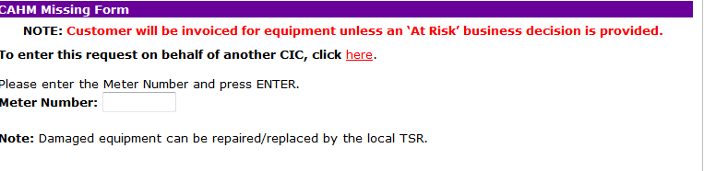

Check the report box and paste the sales comments from the ARF into the comments section.
Then Submit.
*After submitted update PID and notify sales “Lost/Stolen has been submitted”.
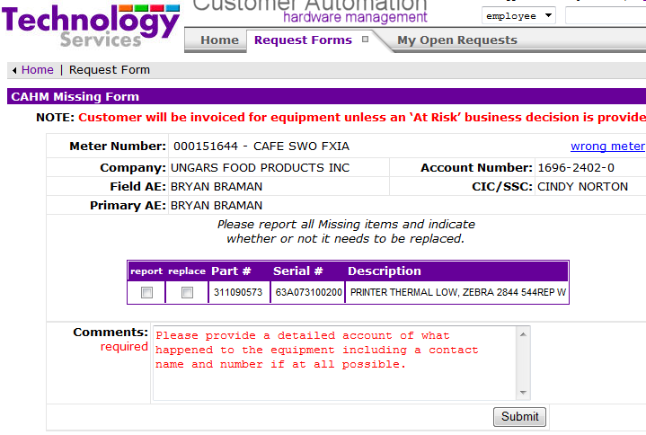

Removals

REMOVAL REQUEST
- AE completes & submits Consultation without Hardware ARF through Pioneer and provides comments with instruction to remove peripheral(s).
*No customer contact required by VSSC.

ORDER ENTRY

- Verify in the INQUIRE SCREEN the type of peripheral currently in place 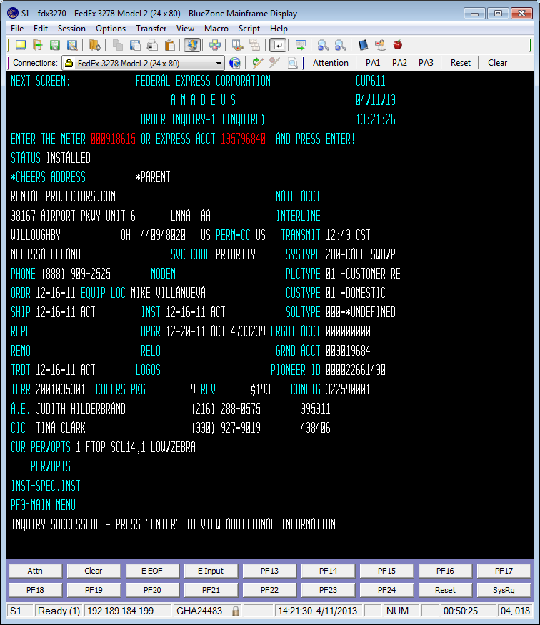
- Type REMOVAL in Next Screen:
- Enter the removal date minimum 5 working days out
- Tab to the corresponding equipment type i.e.: Low/Zebra use F8 to page down for additional printer types
- Enter the number of pieces to be removed
- If the contact name and phone number are different on the REMOVAL SCREEN, the VSSC will update to match the Pioneer Request.
- Enter the email address or type “shipping” in the location field in the REMOVAL SCREEN
- Done by CIC or TECH enter T
- Tab and place an X in front of the removal reason COMPLIANCE
- If there are specific comments provided by AE, enter into the COMMENTS and SPEC. INSTRUCTION sections
- Press ENTER
- Answer Y to confirmation

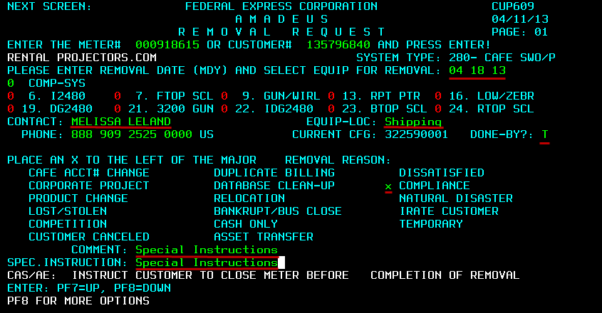

Completing Removal

- Email the AE a message via Nexus Email: “The Peripheral Removal has been entered with an expiration date of xx/xx. Command and Control will contact the customer to arrange the return”.

- Select Completed as the Completion code

- Save

END OF DOCUMENT

